Mass Air Flow Sensor

Output signal of MAF, made by BOSCH is a variable voltage in the range 1 - 5V, whose value depends on the mass of air flow through the sensor. At zero air flow (engine stopped) the sensor output voltage should be equal to 0.98V - 1.02V. Otherwise, the sensor is considered damaged. Increasing the air flow leads to increase of the sensor’s output voltage. This sensor can also detect the reverse air flows from the intake manifold to the air filter. Output voltage in this case reduced below 1V, proportional to the size of the return air flow.

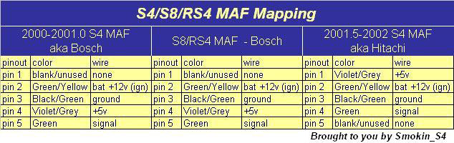
BOSCH 0280218063

2000-2006 | Audi | A4 | 1.8L
2001-2005 | Audi | A4 Quattro | 1.8L
2001-2006 | Audi | TT | ALL
2001-2002 | Audi | TT Quattro AWP | ALL
2001-2004 | Volkswagen | Beetle | 1.8L
2000-2006 | Volkswagen | Golf | 1.8L
2000-2005 | Volkswagen | Jetta | 1.8L
2001-2002 | Volkswagen | Passat | 1.8L

Connector Part Number is 1J0973775A

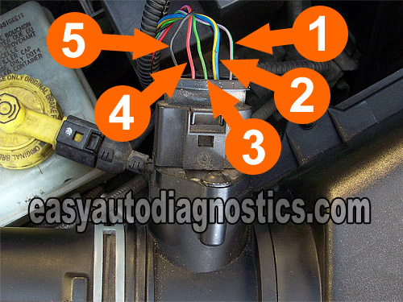
The MAF connector has slots for 5 wires. On some vehicles, only 4 slots are used and the fifth one is empty.
Number 5 = MAF Signal
Number 4 = 5 Volt Reference from ECM.
Number 3 = Ground. Provided by the ECM internally.
Number 2 = 12 Volt battery power.
Number 1 = Air Temp Sensor Circuit. This slot may be empty or not on your MAF sensor.

